Cooking Terminology Worksheet

Using the internet or the textbook, Culinary Essentials, define the following terms and use the term in a sentence.

Example:

- Baste: to moisten food with melted fats, pan drippings, or another liquid during cooking.
Sentence: When making a turkey for Thanksgiving, the chef basted the turkey in its own juices.
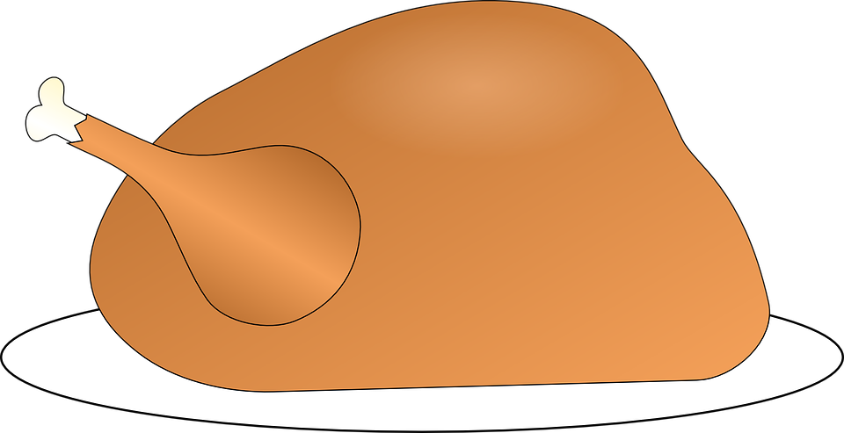

- Beat:

Sentence:
- Blend:

Sentence:
- Coat:

Sentence:

- Chop:

Sentence:
- Combine:

Sentence:
- Cream:

Sentence:
- Dice:

Sentence:
- Knead:

Sentence:

- Mix:

Sentence:
- Scald:

Sentence:
- Shred:

Sentence:
- Sift:

Sentence:
- Whip:

Sentence:

- Simmer:

Sentence:
- Saute:

Sentence:
- Roast:

Sentence:

